Faça a configuração da rede normalmente e depois faça as configurações abaixo:

CONFIGURAÇÃO REDE ROUTER 0

**Configure the ISAKMP Phase 1 properties on R1**

Protocolo ISAKMP de negociação

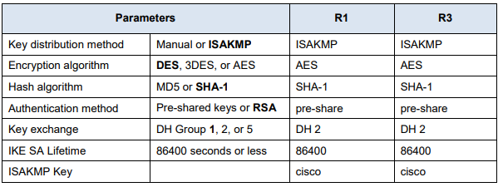

crypto isakmp policy 10

authentication pre-share

hash sha

encryption aes 256

group 2

lifetime 86400

exit

crypto isakmp key toor address 10.0.0.2 (Router 1)

**Configure the ISAKMP Phase 2 properties on R1**

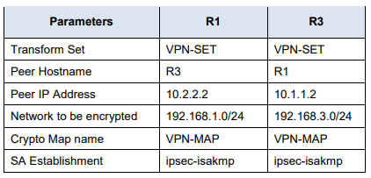

crypto ipsec transform-set TSET esp-aes esp-sha-hmac

access-list 101 permit ip 192.168.1.0 0.0.0.255 192.168.2.0 0.0.0.255

crypto map CMAP 10 ipsec-isakmp

set peer 10.0.0.2

match address 101

set transform-set TSET

exit

**Configure the crypto map on the outgoing interface**

interface fa0/0 (observar a entrada física do roteador)

crypto map CMAP

do wr

CONFIGURAÇÃO REDE ROUTER 1

crypto isakmp policy 10

authentication pre-share

hash sha

encryption aes 256

group 2

lifetime 86400

exit

crypto isakmp key toor address 10.0.0.1 (Router 0)

crypto ipsec transform-set TSET esp-aes esp-sha-hmac

access-list 101 permit ip 192.168.2.0 0.0.0.255 192.168.1.0 0.0.0.255

crypto map CMAP 10 ipsec-isakmp

set peer 10.0.0.1

match address 101

set transform-set TSET

exit

**Configure the crypto map on the outgoing interface**

interface fa0/0 (observar a entrada física do roteador)

crypto map CMAP

do wr

COMANDOS PARA VERIFICAÇÃO

show crypto isakmp sa

show crypto ipsec as